#### MINI PROJECT REPORT

**on**

**Car Rental System Submitted as partial fulfilment of**

# MASTER OF COMPUTER APPLICATION DEGREE

**SESSION 2023-24**

#### By Saurabh Saroha 2200320140146

**Under the guidance of NAME OF INTERNAL GUIDE(Mentor) (DESIG. OF INTERNAL GUIDE(Mentor))**

**ABES ENGINEERING COLLEGE, GHAZIABAD (032)**



#### AFFILIATED TO

**Dr. A.P.J ABDUL KALAM TECHNICAL UNIVERSITY, UTTAR PRADESH LUCKNOW**

Ref. No.:- ABES/ MCA /2023-24/001 Date: DD/MM/YYYY

**TO WHOMSOEVER IT MAY CONCERN**

This is to certify that Mini Project bearing title "<<Project Title>>" is a bonafide record of project work done successfully by Mr./ Ms. <<Student Name>> (<<Roll No.: ……………>>”) of MCA-III semester under my supervision in partial fulfillment for the award of the degree in Master of computer Application from Dr. A.P.J. Abdul Kalam Technical University, Lucknow during the session 2023-24.

Dr. /Mr./Ms. <<Mentor Name>>

<<Designation>>

Prof.(Dr.) Devendra Kumar

Internal Guide Head of Department

MCA Dept. MCA Dept

**STUDENT DECLARATION**

I hereby declare that the work being presented in this report entitled “**<<Project Title>>”** is an authentic record of my own work carried out under the supervision of **“<<Mentor / Internal Guide Name>>”.**

#### Date: Signature of Student

**<<Student Name>>**

This is to certify that the above statement made by the candidate is correct to the best of my knowledge.

#### Signature of HOD Signature of Internal Prof.( Dr.) Devendra Kumar <<Mentor Name>> HOD-MCA <<Designation>>

**Date:**

## ACKNOWLEDGEMENT

Any software project is not a work of an individual. It combines effort, ideas, suggestions, reviews, and hard work. I thank all who initiated and helped us to complete my project. One of the most pleasing aspects of collecting the necessary information and compiling it is the opportunity to thank those who have actively contributed to it.

I would like to thank my guide for his/her guidance and cooperation render for following me to undergo training under his/her guidance; I am also thanks to all the other college staff who helped me despite their busy schedule.

My special thanks to **<<Mentor Name>>, <<Designation>>** for his active support, affectionate, guidance and constant encouragement.

I am highly indebted to **Prof. (Dr.) Devendra Kumar (HOD-MCA)** for his continuous effort in building a good infrastructure and developing a professional attitude within ourselves during the academic period of MCA (Master of Computer Application).

#### Signature of Student

**<<Student Name>>**

**<<Roll No.>> MCA-III Semester**

## ABSTRACT

Today most of the colleges are using either manual system for registration in college event’s activity or they have lots of paperwork and they are using desktop, spread sheet like MS Excel application to manage data in soft copy about student’s registration. In this proposed Online Events Registration System, it will run on a server and the user can handle whole the registration activities. It has facilities to generate several types of reports (like pdf, excel) which are required by the management during event organizing.

This application maintains the centralized database so that any changes done at a location reflects immediately. This is an online tool so more than one user can login into the system and use the tool simultaneously.

The aim of this application is to reduce the manual effort needed to manage transactions and historical data used in various god owns. Also, this application provides an interface to users to view the details about events.

**TABLE OF CONTENT**

|  |  |  |  |  |
| --- | --- | --- | --- | --- |
| **Sr.**  **No.** | **Content** | | | **Page No.** |
| 1. | Introduction | | | 1 |
|  | 1.1 | Objective | | 2 |
|  | 1.2 | Problem Statement | | 3 |
|  | 1.3 | Problem Definition | | 4 |
| 2. | Feasibility Study | | | 5 |
|  | 2.1 | | Technical | 5 |
|  | 2.2 | | Operational | 5 |
|  | 2.3 | | Economic | 5 |
|  | 2.4 | | Cost Estimation | 6 |
| 3 | Requirements | | | 7 |
|  | 3.1 | Technologies Used | | 8 |
|  | 3.2 | Functional Requirements | | 10 |
|  | 3.3 | Non-Functional Requirements | | 11 |
| 4 | Design | | | 12 |
|  | 4.1 | Model View Controller(MVC) Diagram | | 12 |
|  | 4.2 | ER-Diagram | | 13 |
|  | 4.3 | Data Flow Diagram(Zero Level DFD) | | 14 |
|  | 4.4 | Use Case | | 15 |
|  | 4.5 | Class Diagram | | 16 |
|  | 4.6 | Deployment Diagram | | 17 |
| 5 | GUI | | | 18 |
|  | 5.1 | | Modules Screenshot | 22 |
| 6 | Coding | | | 22 |
| 7 | Timeline of Project | | | 64 |
| 8 | Gantt Chart | | | 65 |

|  |  |  |
| --- | --- | --- |
| 9 | Future Scope | 66 |
| 10 | Conclusion | 67 |
| 10 | References | 68 |

## LIST OF FIGURES

|  |  |  |
| --- | --- | --- |
| **S. No.** | **Topic** | **Page No.** |
| Figure-1 | MVC Diagram | 5 |
| Figure-2 | ER-Diagram | 9 |
| Figure-3 | 0 level DFD | 9 |
| Figure-4 | Use Case Diagram | 10 |
| Figure-5 | Class Diagram |  |
| Figure-6 | Deployment Diagram |  |

**LIST OF TABLES**

|  |  |  |
| --- | --- | --- |
| **S. No.** | **Topics** | **Page No.** |
| Table-1 | Timeline of Project | 15 |
| Table -2 | Gantt Chart | 19 |

# CAR RENTAL SYSTEM

### INTRODUCTION

This project is designed to be used by Car Rental Company specializing in renting cars to customers. Customers can view available cars, register, view profiles, and reserve automobiles using this online system. It involves developing a car rental system for a company that rents cars.

This system will be a web-based application. Car rental businesses provid

d for vehicles for temporal use. For those individuals that own a

tal business is growing at a very rapid rate as there is increased

ily basis. Because of the convenience of moving around in a car,

e vehicles for hire at a fee, normally charged either on an hourly

or a da car ren deman

car may use car rental services when their cars broke down or waiting for insurance clearance whereas for those that do not own a car may need to use a hired car to get to their destinations rather than using public transport. For this reason, car hire business is growing very rapidly, most car rental businesses now have multiple outlets in various cities, and hence the need to have a well-designed and advance system that car-hire companies can use to manage staff, vehicles, drivers, and customers. This project give rise to a car hire system that can be used by small, medium, or large car hire organizations.

### OBJECTIVE

The main objective of the Project on Car Rental System is to manage the details of Car, Customer, Payment, Booking, Insurance. It manages all the information about Car, Supplier, Insurance, Car. The project is totally built at administrative end and thus only the administrator is guaranteed the access. The purpose of the project is to build an application program to reduce the manual work for managing the Car, Customer,

Supplier, Payment. It tracks all the details about the Payment, Booking, Insurance.

Functionalities provided by car Rental System are as follows:

* Provides the searching facilities based on various factors. Such as Car, Payment, Booking, Insurance
* Car Rental System also manage the Supplier details online for booking details, Insurance details, Car.
* It tracks all the information of Customer, Supplier, Booking etc.
* Manage the information of Customer
* Shows the information and description of the car, payment
* To increase efficiency of managing the car, customer
* It deals with monitoring the information and transactions of booking
* Manage the information of car
* Manage the information of booking

### Problem Statement:

A car rental is a vehicle that can be used temporarily for a fee during a specified period. Getting a rental car helps people get around despite the fact they do not have access to their own personal vehicle or don't own a vehicle at all. The individual who needs a car must contact a rental car company and contract out for a vehicle. This system increases customer retention and simplify vehicle and staff management.

### Aims & Objectives:

* To produce a web-based system that allow customer to register and reserve car online and for the company to effectively manage their car rental business.
* To ease customer's task whenever they need to rent a car.

#### Problem Definition

A car rental is a vehicle that can be used temporarily for a fee during a specified period. Getting a rental car helps people get around despite the fact they do not have access to their own personal vehicle or don't own a vehicle at all. The individual who needs a car must contact a rental car company and contract out for a vehicle. This system increases customer retention and simplify vehicle and staff management.

#### Paper-based processes

Owner of cars are burdened by cumbersome paperwork and manual processes, and they find it difficult to maintain records of customers, cars etc., and track the information they need. Using Car Rental System, automate these processes to save time and reduce staff workload.

#### Online Registration

Customers no more have to stand for hours in the queue to pay rent. Simplify registration and fee collections with online forms, with the ability to send automatic notifications, alerts and reminders via email, SMS alerts and push notifications from mobile devices.

#### Revenue Management

It is difficult for car owners to cope with their finances and track their fee collections and contributions. Seamlessly connect and engage with customers to strengthen relationship and drive greater success.

### FEASIBILITY STUDY

At this stage, the analyst estimates the urgency of the project and estimates the development cost.

In feasibility analysis, we have to study the following:

#### l) Technical Feasibility:

Technical feasibility is concerned with the availability of hardware and software required for the development of the system, to see compatibility and maturity of the technology proposed to be used and to see the availability of the required technical manpower to develop the system. After the study we came to conclusion that we proceed further with the tools and development environment chosen by us. This was important in our case as we were working on two various phases of the department that will need to be integrated in future to make an extended system.

#### Operational Feasibility:

Operational feasibility is all about problems that may arise during operations. There are two aspects related with this issue:

* + What is the probability that the solution developed may not put to use or may not work?
  + What is the inclination of the management and end users towards the solution? Though, there is very least possibility of management being averse to the solution, there is a significant probability that the end users may not be interested in using the solution due to lack of training, insight etc.

#### Economic Feasibility:

It is the measure of cost effectiveness of the project. The economic feasibility is nothing but judging whether the possible benefit of solving the problems is worthwhile of not. At the feasibility study level, it is impossible to estimate the cost because member's requirements and alternative solutions have not been identified at this stage. However, when the specific requirements and solutions have been identified, the analyst weighs the cost and benefits of all solutions, this is called "cost benefit analysis.

### COST ESTIMATION

Software cost comprises a small percentage of overall computer- based system cost. There are a number of factors, which are considered, that can affect the ultimate cost of the software such as - human, technical, Hardware and Software availability etc. The main point that was considered during the cost estimation of project was its sizing. In spite of complete software sizing, function point and approximate lines of code were also used to "size" each element of the Software and their costing. The cost estimation done by me for Project also depend upon the baseline metrics collected from past projects and these were used in conjunction with estimation variables to develop cost and effort projections.

We have basically estimated this project mainly on two bases -

1) Effort Estimation - This refers to the total man-hours required for the development of the project. It even includes the time required for doing documentation and user manual.

Hardware Required Estimation - This includes the cost of the PCs and the hardware cost required for development of this project.

#### Requirement Analysis

User Management**:**

* Registration and login for customers.
* Registration and login for administrators. Car Inventory:
* Add, edit, and delete car details (model, make, year, registration number, etc.).
* Categorize cars (e.g., sedan, SUV, luxury).
* Specify rental rates and availability status. Reservation System:
* Search and filter cars based on criteria (e.g., date, type, availability).
* View details of available cars, including images and specifications.
* Reserve a car for a specific date and time.
* Provide confirmation of the reservation. Booking Management:
* View and manage existing reservations.
* Cancel a reservation.
* Calculate and display rental costs based on duration and car type. User Profile:
* View and edit personal information.
* View rental history and invoices.
* Change password and update contact details. Admin Features:
* Monitor and manage user accounts.
* Monitor and manage car inventory.
* Generate reports (e.g., rental history, revenue).

#### Technologies Used:

* + **PHP:**

PHP is an acronym for "PHP: Hypertext Pre-processor". PHP is a server scripting language, and a powerful tool for making dynamic and interactive Web pages. PHP is a widely-used, free, and efficient alternative to competitors such as Microsoft's ASP.

* + **HTML:**

The Hyper Text Mark-up Language or HTML is the standard mark-up language for documents designed to be displayed in a web browser. It can be assisted by technologies such as Cascading Style Sheets and scripting languages such as JavaScript.

#### CSS:

Cascading Style Sheets is a style sheet language used for describing the presentation of a document written in a mark-up language such as HTML or XML. CSS is a cornerstone technology of the World Wide Web, alongside HTML and JavaScript.

* + **MYSQL:**

MySQL is an Oracle-backed open source relational database management system based on Structured Query Language. MySQL runs on virtually all platforms, including Linux, UNIX and Windows. Although it can be used in a wide range of applications, MySQL is most often associated with web applications and online publishing.

* + **XAMPP:**

XAMPP is a free and open-source cross-platform web server solution stack package developed by Apache Friends, consisting mainly of the Apache HTTP Server, MariaDB database, and interpreters for scripts written in the PHP and Perl programming languages.

* + **Text Editor or VS-code:**

A text editor is a type of computer program that edits plain text. Such programs are sometimes known as "notepad" software.

#### Functional Requirements

User Registration and Authentication:

* Users should be able to register with the system using valid information.
* The system should authenticate users during login. Car Inventory Management:
* Add, edit, and delete car details including model, make, year, registration number, etc.
* Categorize cars into types (e.g., sedan, SUV, luxury). Reservation System:
* Users should be able to search and filter available cars based on criteria such as date, type, and availability.
* Users can view details of available cars, including images and specifications.
* Reserve a car for a specific date and time.
* Provide confirmation of the reservation. Search and Filter:
* Provide advanced search and filter options for users to find specific cars. Responsive Design:
* Ensure the system is accessible and usable across various devices (desktop, tablet, mobile).

Localization:

* Support multiple languages and currencies if the system is intended for use in diverse regions.

#### Non-Functional Requirements:

Performance:

* The system should be responsive and provide quick search results.
* Handle a specified number of concurrent users without significant performance degradation.

Reliability:

* The system should be available 24/7 with minimal downtime.
* Implement mechanisms for data backup and recovery. Scalability:
* Design the system to handle a growing number of users and cars.
* Easily scale the infrastructure to accommodate increased demand. Usability:
* The user interface should be intuitive and user-friendly.
* Provide clear and concise instructions for users. Security:
* Protect user data with encryption during transmission and storage.
* Regularly update and patch software to address security vulnerabilities. Compatibility:
* Ensure compatibility with popular web browsers and devices.
* Support various operating systems. Availability:
* Aim for high system availability, with a minimum of 99% uptime.
* Implement measures to handle scheduled maintenance without disrupting services.

**DESIGN PHASE**

**MVC (Model View Controller Flow) Diagram**

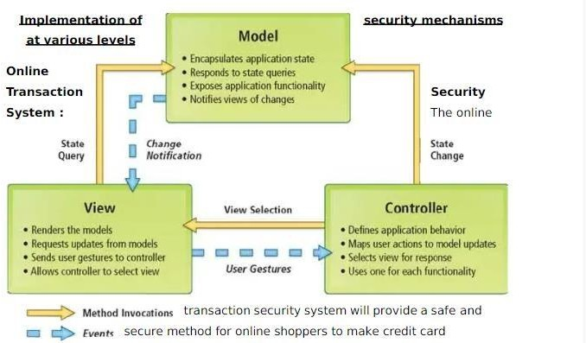

### ER-DIAGRAM

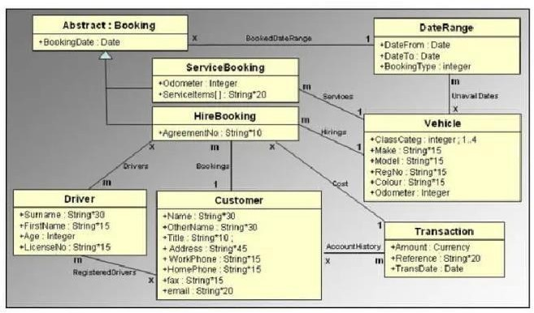

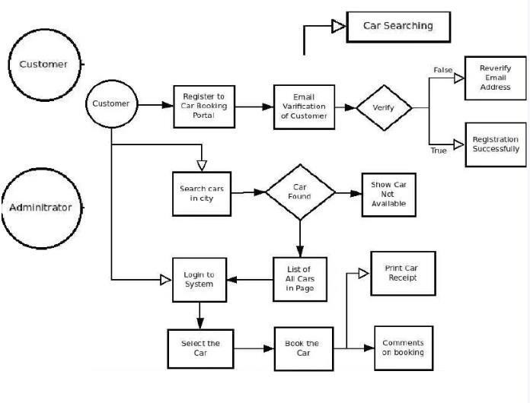**Zero Level DFD**

### USE CASE DIAGRAM

**CLASS DIAGRAM**

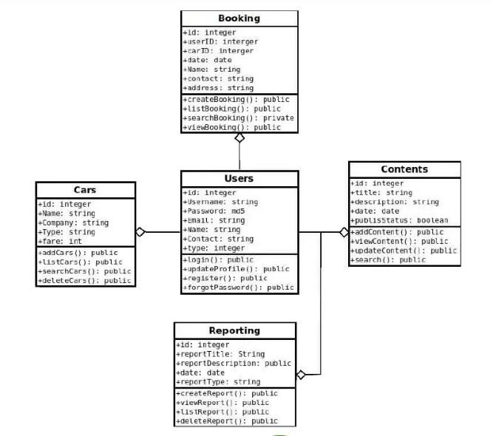

### DEPLOYMENT DIAGRAM

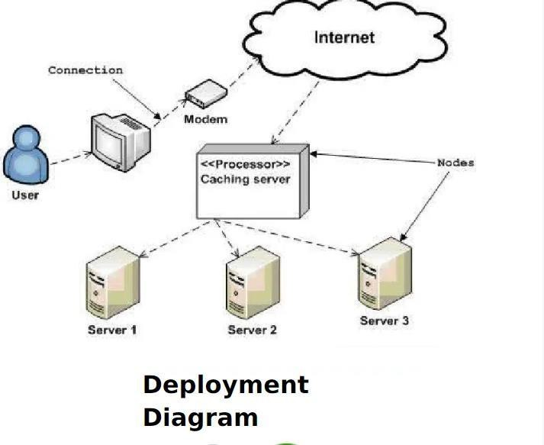

#### GUI

**Modules Screenshot**

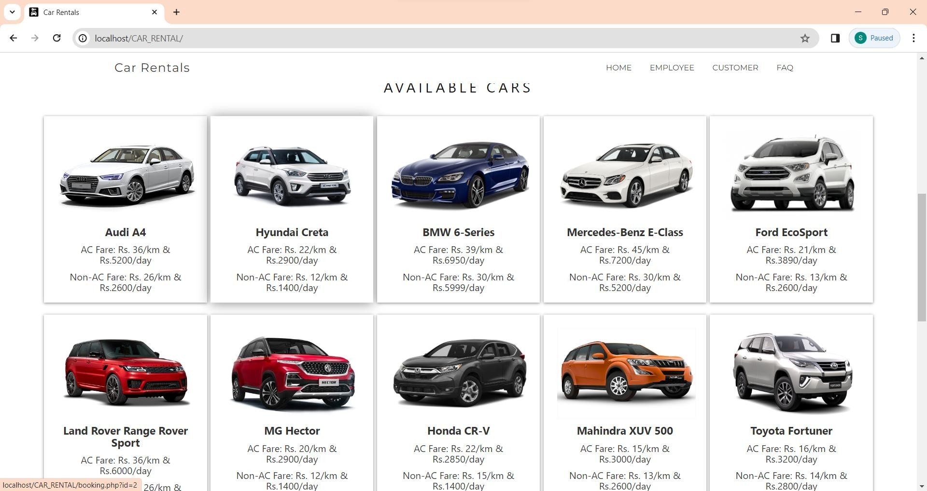

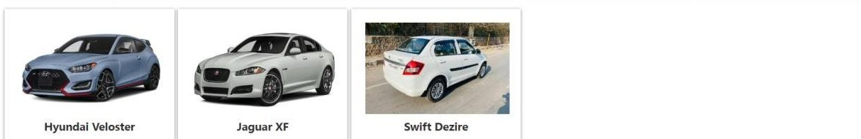

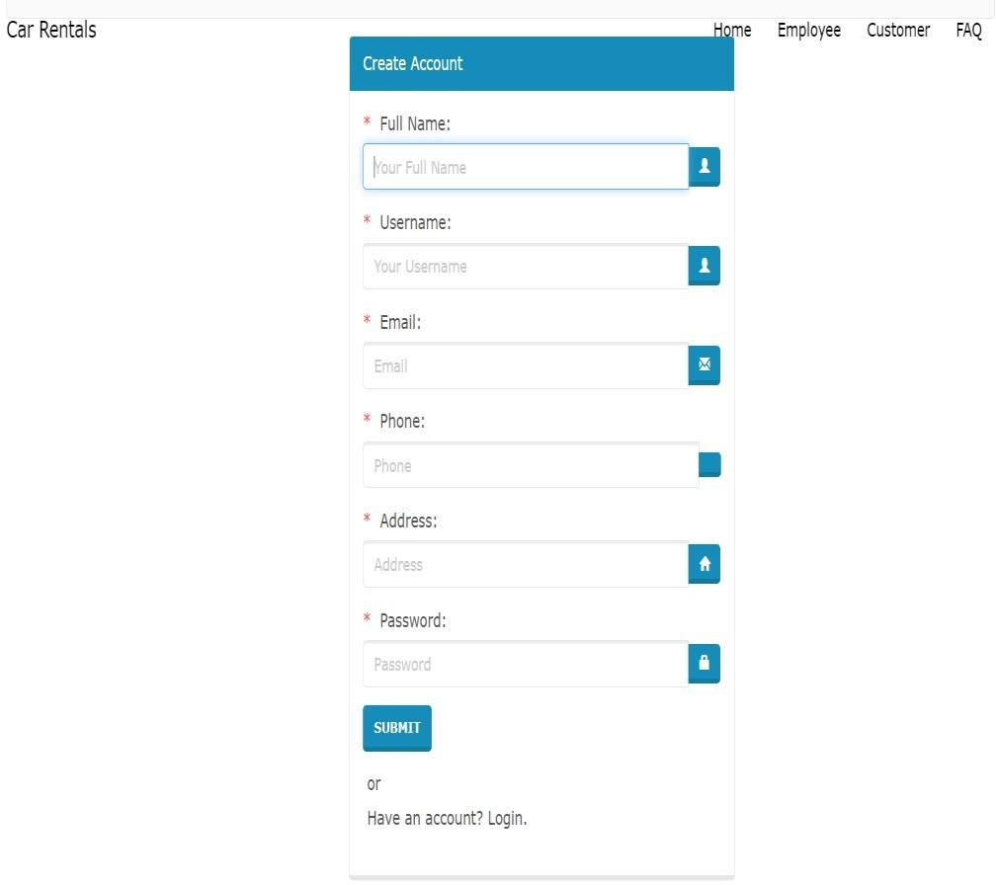

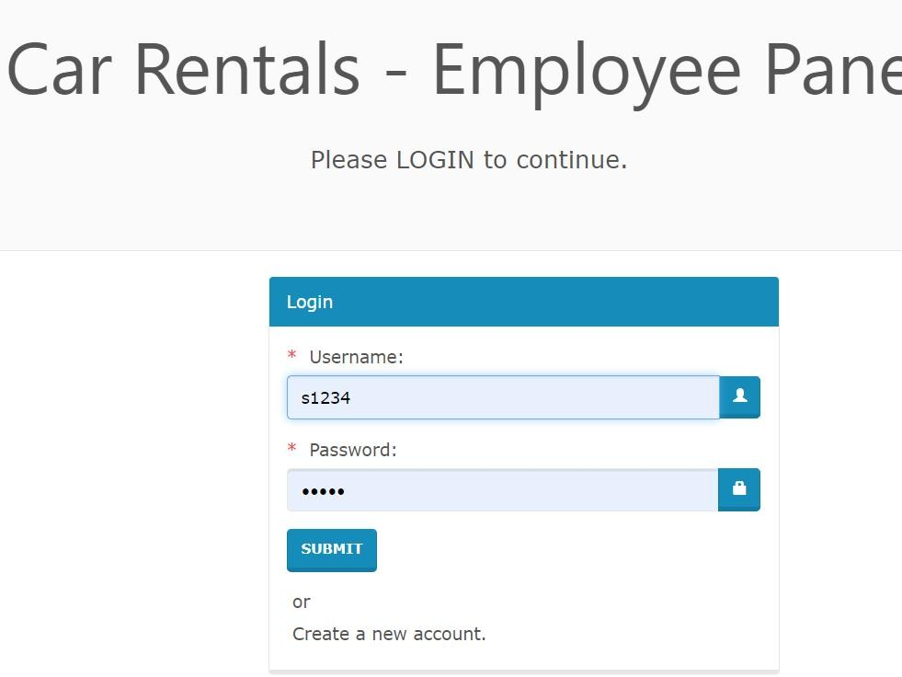

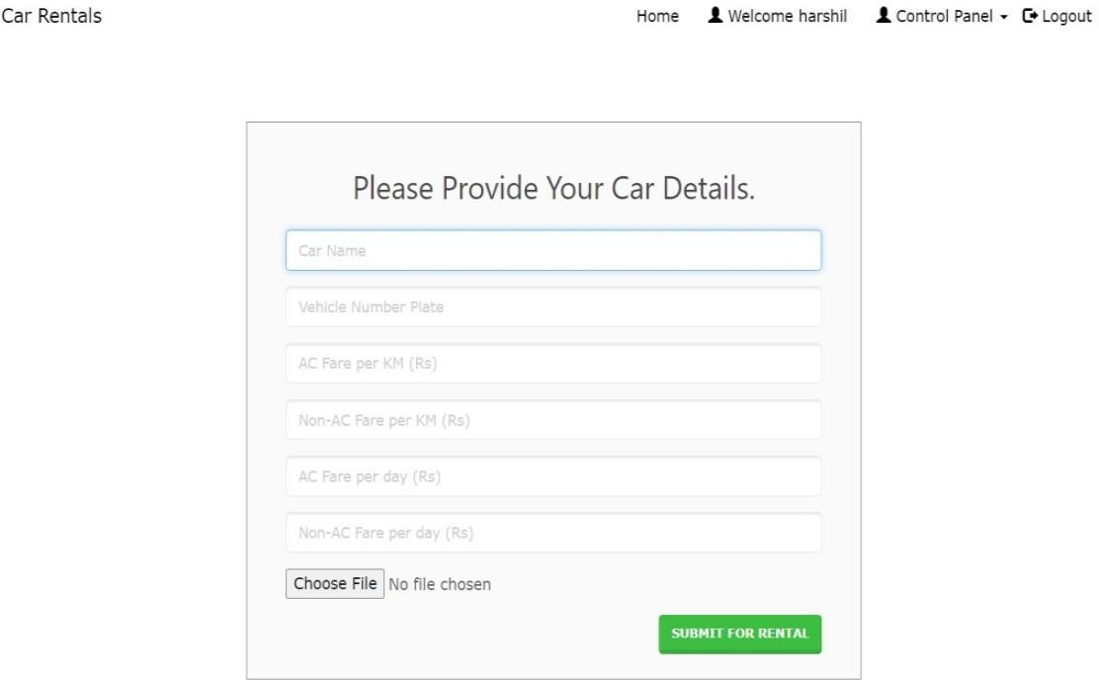

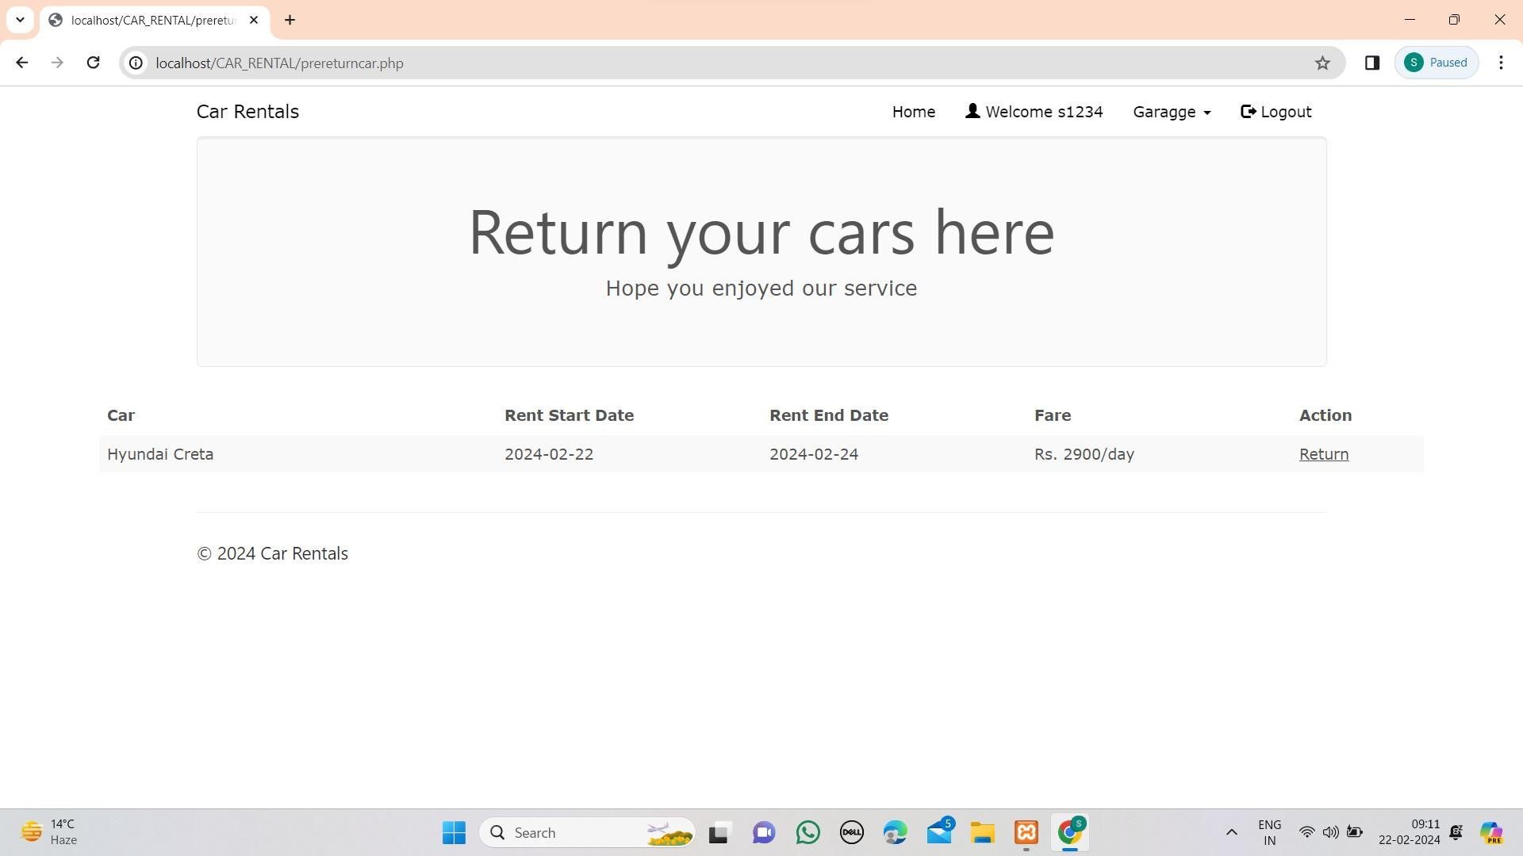

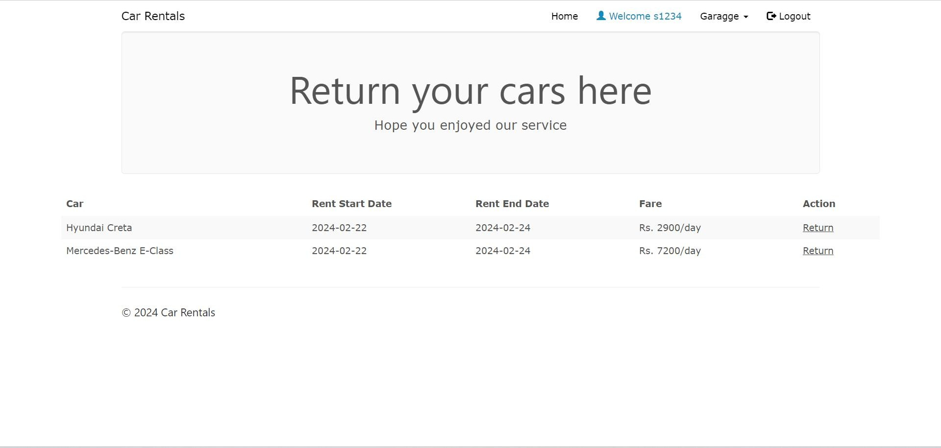

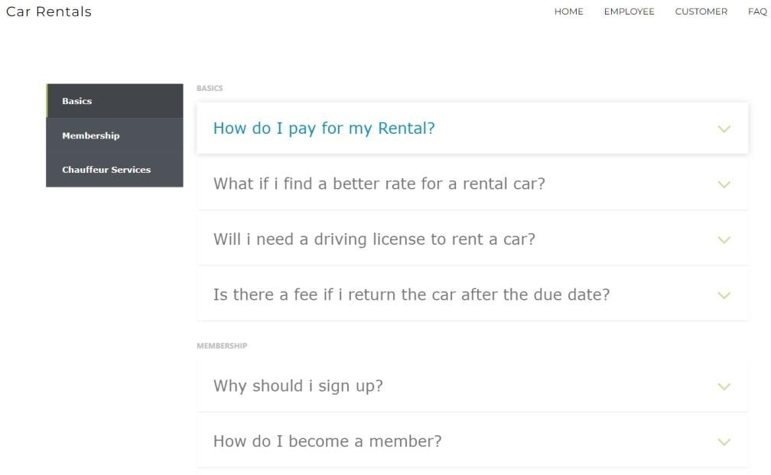

#### CODING PHASE

PHP

#### Connection.php

<?php function Connect()

{

$dbhost = "localhost";

$dbuser = "root";

$dbpass = "";

$dbname = "carrentalp";

//Create Connection

$conn = mysqli_connect($dbhost, $dbuser, $dbpass, $dbname) or die($conn->connect_error);

return $conn;

}

?>

#### action_page.php

<!DOCTYPE html>

<html> <?php session_start(); require 'connection.php';

$conn = Connect();

?>

<head>

<meta charset="utf-8">

<meta name="viewport" content="width=device-width, initial- scale=1.0">

<title>Car Rentals</title>

<link rel="shortcut icon" type="image/png" href="assets/img/P.png.png">

<link rel="stylesheet" href="https://fonts.googleapis.com/css?family=Lato">

<link rel="stylesheet" href="assets/bootstrap/css/bootstrap.min.css">

<link rel="stylesheet" href="assets/fonts/font-awesome.min.css">

<link rel="stylesheet" href="assets/css/user.css">

<link rel="stylesheet" href="assets/w3css/w3.css">

<link href="[http://fonts.googleapis.com/css?family=Open+Sans:300,400,700,](http://fonts.googleapis.com/css?family=Open%2BSans%3A300%2C400%2C700) 400itali c,700italic" rel="stylesheet" type="text/css">

<link href="[http://fonts.googleapis.com/css?family=Montserrat:400,700](http://fonts.googleapis.com/css?family=Montserrat%3A400%2C700)" rel="stylesheet" type="text/css">

</head>

<body>

<?php

$name = $conn->real_escape_string($_POST['name']);

$e_mail = $conn->real_escape_string($_POST['e_mail']);

$message = $conn->real_escape_string($_POST['message']);

$sql = "INSERT INTO feedback values ('" . $name . "','" .

$e_mail ."','" . $message ."')";

$success = $conn->query($sql); if(!$success)

{ echo

$conn->error;

}

els e

{ ?

>

<div class="container">

<div class="jumbotron" style="text-align: center;"> Thank you for your feedback!

<br><br>

<a href="index.php" class="btn btn-default"> Go Back </a>

</div>

<?php

}

?>

</body>

<footer class="site-footer">

<div class="container">

<hr>

<div class="row">

<div class="col-sm-6">

<h5>© <?php echo date("Y"); ?> Car Rentals</h5>

</div>

</div>

</div>

</footer>

</html>

#### booking.php

<!DOCTYPE html>

<html> <?php include('session_customer.php'); if(!isset($_SESSION['login_custo mer'])){

session_destroy(); header("location:

customerlogin.php");

}

?>

<title>Book Car </title>

<head>

<script type="text/javascript" src="assets/ajs/angular.min.js">

</script>

<link rel="stylesheet" href="https://fonts.googleapis.com/css?family=Lato">

<link rel="shortcut icon" type="image/png" href="assets/img/P.png.png">

<link rel="stylesheet" href="assets/bootstrap/css/bootstrap.min.css">

<link rel="stylesheet" href="assets/fonts/font-awesome.min.css">

<link rel="stylesheet" href="assets/w3css/w3.css">

<script type="text/javascript" src="assets/js/jquery.min.js"></script>

<script type="text/javascript" src="assets/js/bootstrap.min.js"></script> <script type="text/javascript" src="assets/js/custom.js"></script>

<link rel="stylesheet" type="text/css" media="screen" href="assets/css/clientpage.css" />

</head>

<body ng-app="">

<!-- Navigation -->

<!-- Navigation -->

<nav class="navbar navbar-custom navbar-fixed-top" role="navigation" style="color: black">

<div class="container">

<div class="navbar-header">

<button type="button" class="navbar-toggle" data- toggle="collapse" data-target=".navbar-main-collapse">

<i class="fa fa-bars"></i>

</button>

<a class="navbar-brand page-scroll" href="index.php"> Car Rentals </a>

</div>

<!-- Collect the nav links, forms, and other content for toggling --

> <?php if(isset($_SESSION['login_client'])){

?>

<div class="collapse navbar-collapse navbar-right navbar- maincollapse">

<ul class="nav navbar-nav">

<li>

<a href="index.php">Home</a>

</li>

<li>

<a href="#"><span class="glyphicon glyphicon-

user"></span>

Welcome <?php echo $_SESSION['login_client']; ?></a>

</li>

<li>

<ul class="nav navbar-nav navbar-right">

<li><a href="#" class="dropdown-toggle active" datatoggle="dropdown" role="button" aria-haspopup="true" aria- expanded="false"><span class="glyphicon glyphicon-user"></span> Control Panel <span class="caret"></span> </a>

<ul class="dropdown-menu">

<li> <a href="entercar.php">Add Car</a></li>

<li> <a href="enterdriver.php"> Add Driver</a></li>

<li> <a href="clientview.php">View</a></li>

</ul>

</li>

</ul>

</li>

<li>

<a href="logout.php"><span class="glyphicon glyphicon- logout"></span> Logout</a>

</li>

</ul>

</div>

<?php

}

else if (isset($_SESSION['login_customer'])){

?>

<div class="collapse navbar-collapse navbar-right navbar- maincollapse">

<ul class="nav navbar-nav">

<li>

<a href="index.php">Home</a>

</li>

<li>

<a href="#"><span class="glyphicon glyphicon-

user"></span>

Welcome <?php echo $_SESSION['login_customer']; ?></a>

</li>

<ul class="nav navbar-nav">

<li><a href="#" class="dropdown-toggle active" datatoggle="dropdown" role="button" aria-haspopup="true" ariaexpanded="false"> Garagge <span class="caret"></span> </a>

<ul class="dropdown-menu">

<li> <a href="prereturncar.php">Return Now</a></li>

<li> <a href="mybookings.php"> My Bookings</a></li>

</ul>

</li>

</ul>

<li>

<a href="logout.php"><span class="glyphicon glyphicon- logout"></span> Logout</a>

</li>

</ul>

</div>

<?php

}

else {

?>

<div class="collapse navbar-collapse navbar-right navbar-

maincollapse">

<ul class="nav navbar-nav">

<li>

<a href="index.php">Home</a>

</li>

<li>

<a href="clientlogin.php">Employee</a>

</li>

<li>

<a href="customerlogin.php">Customer</a>

</li>

<li>

<a href="#"> FAQ </a>

</li>

</ul>

</div>

<?php }

?>

<!-- /.navbar-collapse -->

</div>

<!-- /.container -->

</nav>

<div class="container" style="margin-top: 65px;" >

<div class="col-md-7" style="float: none; margin: 0 auto;">

<div class="form-area">

<form role="form" action="bookingconfirm.php" method="POST">

<br style="clear: both">

<br>

<?php

$car_id = $_GET["id"];

$sql1 = "SELECT * FROM cars WHERE car_id = '$car_id'";

$result1 = mysqli_query($conn, $sql1); if(mysqli_num_rows($result1)){ while ($row1 =

mysqli_fetch_assoc($result1)){ $car

_name = $row1["car_name"];

$car_nameplate = $row1["car_nameplate"];

$ac_price = $row1["ac_price"];

$non_ac_price = $row1["non_ac_price"];

$ac_price_per_day = $row1["ac_price_per_day"];

$non_ac_price_per_day = $row1["non_ac_price_per_day"];

}

}

?>

<!-- <div class="form-group"> -->

<h5> Selected Car:&nbsp; <b><?php echo($car_name);?></b></h5> <!-- </div> -->

<!-- <div class="form-group"> -->

<h5> Number Plate:&nbsp;<b> <?php echo($car_nameplate);?></b></h5>

<!-- </div> -->

<!-- <div class="form-group"> -->

<?php $today = date("Y-m-d") ?>

<label><h5>Start Date:</h5></label>

<input type="date" name="rent_start_date" min="<?php echo($today);?>" required="">

&nbsp;

<label><h5>End Date:</h5></label>

<input type="date" name="rent_end_date" min="<?php echo($today);?>" required="">

<!-- </div> -->

<h5> Choose your car type: &nbsp;

<input onclick="reveal()" type="radio" name="radio" value="ac" ngmodel="myVar"> <b>With AC </b>&nbsp;

<input onclick="reveal()" type="radio" name="radio" value="non_ac" ng-model="myVar"><b>With-Out AC </b>

<div ng-switch="myVar">

<div ng-switch-default>

<!-- <div class="form-group"> -->

<h5>Fare: <h5>

<!-- </div> -->

</div>

<div ng-switch-when="ac">

<!-- <div class="form-group"> -->

<h5>Fare: <b><?php echo("Rs. " . $ac_price . "/km and Rs. " .

$ac_price_per_day . "/day");?></b><h5>

<!-- </div> -->

</div>

<div ng-switch-when="non_ac">

<!-- <div class="form-group"> -->

<h5>Fare: <b><?php echo("Rs. " . $non_ac_price . "/km and Rs. " . $non_ac_price_per_day . "/day");?></b><h5>

<!-- </div> -->

</div>

</div>

<h5> Charge type: &nbsp;

<input onclick="reveal()" type="radio" name="radio1" value="km"><b> per KM</b> &nbsp;

<input onclick="reveal()" type="radio" name="radio1" value="days"><b> per day</b>

<br><br>

<!-- <form class="form-group"> --> Select a driver: &nbsp;

<select name="driver_id_from_dropdown" ng- model="myVar1">

<?php

$sql2 = "SELECT * FROM driver d WHERE d.driver_availability = 'yes' AND d.client_username IN (SELECT cc.client_username FROM clientcars cc WHERE cc.car_id = '$car_id')";

$result2 = mysqli_query($conn, $sql2); if(mysqli_num_rows($result2) >

0){ while($row2 = mysqli_fetch_assoc($result2)){ $driv er_id = $row2["driver_id"];

$driver_name = $row2["driver_name"];

$driver_gender = $row2["driver_gender"];

$driver_phone = $row2["driver_phone"];

?>

<option value="<?php echo($driver_id); ?>"><?php echo($driver_name); ?>

<?php }} else{

?>

Sorry! No Drivers are currently available, try again later...

<?php

}

?>

</select>

<!-- </form> -->

<div ng-switch="myVar1">

<?php

$sql3 = "SELECT * FROM driver d WHERE d.driver_availability = 'yes' AND d.client_username IN (SELECT

cc.client_username FROM clientcars cc WHERE cc.car_id = '$car_id')";

$result3 = mysqli_query($conn, $sql3);

if(mysqli_num_rows($result3) >

0){ while($row3 = mysqli_fetch_assoc($result3)){

$driver_id = $row3["driver_id"];

$driver_name = $row3["driver_name"];

$driver_gender = $row3["driver_gender"];

$driver_phone = $row3["driver_phone"];

?>

<div ng-switch-when="<?php echo($driver_id); ?>">

<h5>Driver Name:&nbsp; <b><?php echo($driver_name); ?></b></h5>

<p>Gender:&nbsp; <b><?php echo($driver_gender); ?></b> </p>

<p>Contact:&nbsp; <b><?php echo($driver_phone); ?></b> </p>

</div>

<?php }} ?>

</div>

<input type="hidden" name="hidden_carid" value="<?php echo $car_id; ?>">

<input type="submit"name="submit" value="Rent Now" class="btn btnwarning pull-right">

</form>

</div>

<div class="col-md-12" style="float: none; margin: 0 auto; text-align: center;">

<h6><strong>Note:</strong> You will be charged with extra

<span class="text-danger">Rs. 500</span> for each day after the due date ends.</h6>

</div>

</div>

</body>

<footer class="site-footer">

<div class="container">

<hr>

<div class="row">

<div class="col-sm-6">

<h5>© <?php echo date("Y"); ?> Car Rentals</h5>

</div>

</div>

</div>

</footer>

</html>

#### bookingconfirm.php

<!DOCTYPE html>

<html>

<?php include('session_customer.php'); if(!isset($_SESSION['login_custo mer'])){

session_destroy(); header("location:

customerlogin.php");

}

?>

<head>

<link rel="stylesheet" href="https://fonts.googleapis.com/css?family=Lato"> <link rel="stylesheet" href="assets/bootstrap/css/bootstrap.min.css">

<link rel="shortcut icon" type="image/png" href="assets/img/P.png.png">

<link rel="stylesheet" href="assets/fonts/font-awesome.min.css">

<link rel="stylesheet" href="assets/w3css/w3.css">

<script type="text/javascript" src="assets/js/jquery.min.js"></script>

<script type="text/javascript" src="assets/js/bootstrap.min.js"></script>

<link rel="stylesheet" type="text/css" media="screen" href="assets/css/bookingconfirm.css" />

</head>

<body>

<?php

$type = $_POST['radio'];

$charge_type = $_POST['radio1'];

$driver_id = $_POST['driver_id_from_dropdown'];

$customer_username = $_SESSION["login_customer"];

$car_id = $conn->real_escape_string($_POST['hidden_carid']);

$rent_start_date = date('Y-m-d', strtotime($_POST['rent_start_date']));

$rent_end_date = date('Y-m-d', strtotime($_POST['rent_end_date']));

$return_status = "NR"; // not returned

$fare = "NA"; function dateDiff($start,

$end) { $start_ts = strtotime($start);

$end_ts = strtotime($end); $diff =

$end_ts - $start_ts;

return round($diff / 86400);

}

$err_date = dateDiff("$rent_start_date", "$rent_end_date");

$sql0 = "SELECT * FROM cars WHERE car_id = '$car_id'";

$result0 = $conn->query($sql0); if (mysqli_num_rows($result0) > 0)

{ while($row0 = mysqli_fetch_assoc($result0)) {

if($type == "ac" && $charge_type == "km"){

$fare = $row0["ac_price"];

} else if ($type == "ac" && $charge_type == "days"){

$fare = $row0["ac_price_per_day"];

} else if ($type == "non_ac" && $charge_type == "km"){

$fare = $row0["non_ac_price"];

} else if ($type == "non_ac" && $charge_type == "days"){

$fare = $row0["non_ac_price_per_day"];

} else {

$fare = "NA";

}

}

}

if($err_date >

= 0) {

$sql1 = "INSERT into rentedcars(customer_username,car_id,driver_id,booking_date,rent_start

_date,re nt_end_date,fare,charge_type,return_status)

VALUES('" . $customer_username . "','" . $car_id . "','" . $driver_id . "','" . date("Y-m-d") ."','" . $rent_start_date ."','" . $rent_end_date . "','" .

$fare . "','" . $charge_type . "','" . $return_status . "')";

$result1 = $conn->query($sql1);

$sql2 = "UPDATE cars SET car_availability = 'no' WHERE car_id = '$car_id'";

$result2 = $conn->query($sql2);

$sql3 = "UPDATE driver SET driver_availability = 'no' WHERE driver_id = '$driver_id'";

$result3 = $conn->query($sql3);

$sql4 = "SELECT * FROM cars c, clients cl, driver d, rentedcars rc WHERE c.car_id = '$car_id' AND d.driver_id = '$driver_id' AND cl.client_username = d.client_username";

$result4 = $conn-

>query($sql4); if (mysqli_num_rows($result4) >

0) { while($row = mysqli_fetch_assoc($result4)) {

$id = $row["id"];

$car_name = $row["car_name"];

$car_nameplate = $row["car_nameplate"];

$driver_name = $row["driver_name"];

$driver_gender = $row["driver_gender"];

$dl_number = $row["dl_number"];

$driver_phone = $row["driver_phone"];

$client_name = $row["client_name"];

$client_phone = $row["client_phone"];

} } if (!$result1 | !$result2

| !$result3){ die("Couldnt enter data: ".$conn->error);

}

?>

<!-- Navigation -->

<nav class="navbar navbar-custom navbar-fixed-top" role="navigation" style="color: black">

<div class="container">

<div class="navbar-header">

<button type="button" class="navbar-toggle" data- toggle="collapse" data-target=".navbar-main-collapse">

<i class="fa fa-bars"></i>

</button>

<a class="navbar-brand page-scroll" href="index.php"> Car Rentals </a>

</div>

<!-- Collect the nav links, forms, and other content for toggling --

>

<?php if(isset($_SESSION['login_client'])){

?>

<div class="collapse navbar-collapse navbar-right navbar- maincollapse">

<ul class="nav navbar-nav">

<li>

<a href="index.php">Home</a>

</li>

<li>

<a href="#"><span class="glyphicon glyphicon-

user"></span>

Welcome <?php echo $_SESSION['login_client']; ?></a>

</li>

<li>

<ul class="nav navbar-nav navbar-right">

<li><a href="#" class="dropdown-toggle active" datatoggle="dropdown" role="button" aria-haspopup="true" aria- expanded="false"><span class="glyphicon glyphicon-user"></span> Control Panel <span class="caret"></span> </a>

<ul class="dropdown-menu">

<li> <a href="entercar.php">Add Car</a></li>

<li> <a href="enterdriver.php"> Add Driver</a></li>

<li> <a href="clientview.php">View</a></li>

</ul>

</li>

</ul>

</li>

<li>

<a href="logout.php"><span class="glyphicon glyphicon- logout"></span> Logout</a>

</li>

</ul>

</div>

<?php

}

else if (isset($_SESSION['login_customer'])){

?>

<div class="collapse navbar-collapse navbar-right navbar- maincollapse">

<ul class="nav navbar-nav">

<li>

<a href="index.php">Home</a>

</li>

<li>

<a href="#"><span class="glyphicon glyphicon-

user"></span>

Welcome <?php echo $_SESSION['login_customer']; ?></a>

</li>

<ul class="nav navbar-nav">

<li><a href="#" class="dropdown-toggle active" datatoggle="dropdown" role="button" aria-haspopup="true" ariaexpanded="false"> Garagge <span class="caret"></span> </a>

<ul class="dropdown-menu">

<li> <a href="prereturncar.php">Return Now</a></li>

<li> <a href="mybookings.php"> My Bookings</a></li>

</ul>

</li>

</ul>

<li>

<a href="logout.php"><span class="glyphicon glyphicon- logout"></span> Logout</a>

</li>

</ul>

</div>

<?php

else {

}

?>

<div class="collapse navbar-collapse navbar-right navbar-

maincollapse">

<ul class="nav navbar-nav">

<li>

<a href="index.php">Home</a>

</li>

<li>

<a href="clientlogin.php">Employee</a>

</li>

<li>

<a href="customerlogin.php">Customer</a>

</li>

<li>

<a href="faq/index.php"> FAQ </a>

</li>

</ul>

</div>

<?php }

?>

<!-- /.navbar-collapse -->

</div>

<!-- /.container -->

</nav>

<div class="container">

<div class="jumbotron">

<h1 class="text-center" style="color: green;"><span class="glyphicon glyphicon-ok-circle"></span> Booking Confirmed.</h1>

</div>

</div>

<br>

<h2 class="text-center"> Thank you for using Car Rental System! We wish you have a safe ride. </h2>

<h3 class="text-center"> <strong>Your Order Number:</strong>

<span style="color: blue;"><?php echo "$id"; ?></span> </h3>

<div class="container">

<h5 class="text-center">Please read the following information about your order.</h5>

<div class="box">

<div class="col-md-10" style="float: none; margin: 0 auto; text- align: center;">

<h3 style="color: orange;">Your booking has been received and placed into out order processing system.</h3>

<br>

<h4>Please make a note of your <strong>order number</strong> now and keep in the event you need to communicate with us about your order.</h4>

<br>

<h3 style="color: orange;">Invoice</h3>

<br>

</div>

<div class="col-md-10" style="float: none; margin: 0 auto; ">

<h4> <strong>Vehicle Name: </strong> <?php echo

$car_name; ?></h4>

<br>

<h4> <strong>Vehicle Number:</strong> <?php echo

$car_nameplate; ?></h4>

<br>

<?php

if($charge_type == "days"){

?>

<h4> <strong>Fare:</strong> Rs. <?php echo

$fare; ?>/day</h4>

<?php } else {

?>

<h4> <strong>Fare:</strong> Rs. <?php echo

$fare; ?>/km</h4>

<?php } ?>

<br>

<h4> <strong>Booking Date: </strong> <?php echo date("Y- m-d"); ?> </h4>

<br>

<h4> <strong>Start Date: </strong> <?php echo

$rent_start_date; ?></h4>

<br>

<h4> <strong>Return Date: </strong> <?php echo

$rent_end_date; ?></h4>

<br>

<h4> <strong>Driver Name: </strong> <?php echo

$driver_name; ?> </h4>

<br>

<h4> <strong>Driver Gender: </strong> <?php echo

$driver_gender; ?> </h4>

<br>

<h4> <strong>Driver License number: </strong> <?php echo

$dl_number; ?> </h4>

<br>

<h4> <strong>Driver Contact:</strong> <?php echo

$driver_phone; ?></h4>

<br>

<h4> <strong>Employee Name:</strong> <?php echo

$client_name; ?></h4>

<br>

<h4> <strong>Employee Contact: </strong> <?php echo

$client_phone; ?></h4>

<br>

</div>

</div>

<div class="col-md-12" style="float: none; margin: 0 auto; text- align: center;">

<h6>Warning! <strong>Do not reload this page</strong> or the above display will be lost. If you want a hardcopy of this page, please print it now.</h6>

</div>

</div>

</body>

<?php } else { ?>

<!-- Navigation -->

<nav class="navbar navbar-custom navbar-fixed-top" role="navigation" style="color: black">

<div class="container">

<div class="navbar-header">

<button type="button" class="navbar-toggle" data- toggle="collapse" data-target=".navbar-main-collapse">

<i class="fa fa-bars"></i>

</button>

<a class="navbar-brand page-scroll" href="index.php"> Car Rentals </a>

</div>

<!-- Collect the nav links, forms, and other content for toggling --

>

<?php

if(isset($_SESSION['login_client'])){

?>

<div class="collapse navbar-collapse navbar-right navbar- maincollapse">

<ul class="nav navbar-nav">

<li>

<a href="index.php">Home</a>

</li>

<li>

<a href="#"><span class="glyphicon glyphicon-

user"></span>

Welcome <?php echo $_SESSION['login_client']; ?></a>

</li>

<li>

<ul class="nav navbar-nav navbar-right">

<li><a href="#" class="dropdown-toggle active" datatoggle="dropdown" role="button" aria-haspopup="true" aria- expanded="false"><span class="glyphicon glyphicon-user"></span> Control Panel <span class="caret"></span> </a>

<ul class="dropdown-menu">

<li> <a href="entercar.php">Add Car</a></li>

<li> <a href="enterdriver.php"> Add Driver</a></li>

<li> <a href="clientview.php">View</a></li>

</ul>

</li>

</ul>

</li>

<li>

<a href="logout.php"><span class="glyphicon glyphicon- logout"></span> Logout</a>

</li>

</ul>

</div>

<?php

}

else if (isset($_SESSION['login_customer'])){

?>

<div class="collapse navbar-collapse navbar-right navbar- maincollapse">

<ul class="nav navbar-nav">

<li>

<a href="index.php">Home</a>

</li>

<li>

<a href="#"><span class="glyphicon glyphicon-

user"></span>

Welcome <?php echo $_SESSION['login_customer']; ?></a>

</li>

<ul class="nav navbar-nav">

<li><a href="#" class="dropdown-toggle active" datatoggle="dropdown" role="button" aria-haspopup="true" ariaexpanded="false"> Garagge <span class="caret"></span> </a>

<ul class="dropdown-menu">

<li> <a href="prereturncar.php">Return Now</a></li>

<li> <a href="mybookings.php"> My Bookings</a></li>

</ul>

</li>

</ul>

<li>

<a href="logout.php"><span class="glyphicon glyphicon- logout"></span> Logout</a>

</li>

</ul>

</div>

<?php

}

else

{ ?>

<div class="collapse navbar-collapse navbar-right navbar- maincollapse">

<ul class="nav navbar-nav">

<li>

<a href="index.php">Home</a>

</li>

<li>

<a href="clientlogin.php">Employee</a>

</li>

<li>

<a href="customerlogin.php">Customer</a>

</li>

<li>

<a href="#"> FAQ </a>

</li>

</ul>

</div>

<?php }

?>

<!-- /.navbar-collapse -->

</div>

<!-- /.container -->

</nav>

<div class="container">

<div class="jumbotron" style="text-align: center;">

You have selected an incorrect date.

<br><br>

</div>

<?php } ?>

<footer class="site-footer">

<div class="container">

<hr>

<div class="row">

<div class="col-sm-6">

<h5>© <?php echo date("Y"); ?> Car Rentals</h5>

</div>

</div>

</div>

</footer> </html>

#### client_registered_success.php

<html>

<head>

<title> Employee Signup | Car Rentals </title>

<link rel="shortcut icon" type="image/png" href="assets/img/P.png.png">

</head>

<link rel="stylesheet" type = "text/css" href

="assets/css/manager_registered_success.css">

<link rel="stylesheet" type = "text/css" href

="assets/bootstrap/css/bootstrap.min.css">

<script type="text/javascript" src="assets/js/jquery.min.js"></script>

<script type="text/javascript" src="assets/js/bootstrap.min.js"></script>

<body>

<button onclick="topFunction()" id="myBtn" title="Go to top">

<span class="glyphicon glyphicon-chevron-up"></span>

</button>

<script type="text/javascript"> window.onscroll = function()

{

scrollFunction()

};

function scrollFunction(){

if (document.body.scrollTop > 20 || document.documentElement.scrollTop

> 20)

{ document.getElementById("myBtn").style.display

= "block";

} else {

document.getElementById("myBtn").style.display = "none";

}

}

function topFunction()

{ document.body.scrollTop = 0; document.documentElement.scrollTop = 0;

}

</script>

<!-- Navigation -->

<nav class="navbar navbar-custom navbar-fixed-top" role="navigation" style="color: black">

<div class="container">

<div class="navbar-header">

<button type="button" class="navbar-toggle" data- toggle="collapse" data-target=".navbar-main-collapse">

<i class="fa fa-bars"></i>

</button>

<a class="navbar-brand page-scroll" href="index.php"> Car Rentals </a>

</div>

<!-- Collect the nav links, forms, and other content for toggling --

>

<?php

if(isset($_SESSION['login_client'])){

?>

<div class="collapse navbar-collapse navbar-right navbar- maincollapse">

<ul class="nav navbar-nav">

<li>

<a href="index.php">Home</a>

</li>

<li>

<a href="#"><span class="glyphicon glyphicon-

user"></span>

Welcome <?php echo $_SESSION['login_client']; ?></a>

</li>

<li>

<ul class="nav navbar-nav navbar-right">

<li><a href="#" class="dropdown-toggle active" datatoggle="dropdown" role="button" aria-haspopup="true" ariaexpanded="false"><span class="glyphicon glyphicon-user"></span> Control Panel <span class="caret"></span> </a>

<ul class="dropdown-menu">

<li> <a href="entercar.php">Add Car</a></li>

<li> <a href="enterdriver.php"> Add Driver</a></li>

<li> <a href="clientview.php">View</a></li>

</ul>

</li>

</ul>

</li>

<li>

<a href="logout.php"><span class="glyphicon glyphicon- logout"></span> Logout</a>

</li>

</ul>

</div>

<?php

}

else if (isset($_SESSION['login_customer'])){

?>

<div class="collapse navbar-collapse navbar-right navbar- maincollapse">

<ul class="nav navbar-nav">

<li>

<a href="index.php">Home</a>

</li>

<li>

<a href="#"><span class="glyphicon glyphicon-

user"></span>

Welcome <?php echo $_SESSION['login_customer']; ?></a>

</li>

<ul class="nav navbar-nav">

<li><a href="#" class="dropdown-toggle active" datatoggle="dropdown" role="button" aria-haspopup="true" ariaexpanded="false"> Garagge <span class="caret"></span> </a>

<ul class="dropdown-menu">

<li> <a href="prereturncar.php">Return Now</a></li>

<li> <a href="mybookings.php"> My Bookings</a></li>

</ul>

</li>

</ul>

<li>

<a href="logout.php"><span class="glyphicon glyphicon- logout"></span> Logout</a>

</li>

</ul>

</div>

else {

<?php

}

?>

<div class="collapse navbar-collapse navbar-right navbar-

maincollapse">

<ul class="nav navbar-nav">

<li>

<a href="index.php">Home</a>

</li>

<li>

<a href="clientlogin.php">Employee</a>

</li>

<li>

<a href="customerlogin.php">Customer</a>

</li>

<li>

<a href="faq/index.php"> FAQ </a>

</li>

</ul>

</div>

<?php }

?>

<!-- /.navbar-collapse -->

</div>

<!-- /.container -->

</nav>

<?php

require 'connection.php';

$conn = Connect();

$client_name = $conn->real_escape_string($_POST['client_name']);

$client_username = $conn-

>real_escape_string($_POST['client_username']);

$client_email = $conn->real_escape_string($_POST['client_email']);

$client_phone = $conn->real_escape_string($_POST['client_phone']);

$client_address = $conn->real_escape_string($_POST['client_address']);

$client_password = $conn-

>real_escape_string($_POST['client_password']);

$query = "INSERT into clients(client_name,client_username,client_email,client_phone,client_ad dress,cl ient_password) VALUES('" . $client_name . "','" .

$client_username . "','" . $client_email . "','" . $client_phone . "','" .

$client_address ."','" . $client_password ."')";

$success = $conn-

>query($query); if (!$success){

die("Couldnt enter data: ".$conn->error);

}

$conn->close();

?>

<div class="container">

<div class="jumbotron" style="text-align: center;">

<h2> <?php echo "Welcome $client_name!" ?> </h2>

<h1>Your account has been created.</h1>

<p>Login Now from <a href="clientlogin.php">HERE</a></p>

</div>

</div>

</body>

<footer class="site-footer">

<div class="container">

<hr>

<div class="row">

<div class="col-sm-6">

<h5>© <?php echo date("Y"); ?> Car Rentals</h5>

</div>

</div>

</div>

</footer>

</html>

### Timeline of the project:

|  |  |
| --- | --- |
| **Project Life cycle** | **Timeline** |
| **Initiating/Defining** | Completed |
| **Planning/Designing** | Completed |
| **Executing/Coding** | Completed |
| **Closing** | Processing |

**Gantt Chart:**

|  |  |  |  |  |
| --- | --- | --- | --- | --- |
|  | Week1 | Week2 | Week3 | Week4 |
| Phase 1 | **Initiating** | **Planning** | **Defining** | **Need** |
| Phase 2 | **Requirement** | **Blue Print** | **Designing** | **Building** |
| Phase 3 | **Front end** | **Development** | **Back end** | **Development** |
| Phase 4 | **Testing** | **Validating** | **Verifying** | **Deploying** |

### Benefits of Online Car Rental Services:

* This online car rental solution is fully functional and flexible.
* It is very easy to use.
* This online car rental system helps in office administration by streamlining and standardizing the procedures.
* It saves a lot of time, money and labour.
* Eco-friendly: The monitoring of the vehicle activity and the overall business becomes easy and includes the least of paper work.
* The software acts as an office that is open 24/7.
* It increases the efficiency of the management at offering quality services to the customers.
* It provides custom features development and support with the software.

### Scope for the project Online Car Rental System:

This project traverses a lot of areas ranging from business concept to computing field, and required to perform several researches to be able to achieve the project objectives.

### CONCLUSION

Car rental business has emerged with a new goodies compared to the past experience where every activity concerning car rental business is limited to a physical location only. Even though the physical location has not been totally eradicated; the nature of functions and how these functions are achieved has been reshaped by the power of internet.

Nowadays, customers can reserve cars online, rent car online, and have the car brought to their door step once the customer is a registered member or go to the office to pick the car.

The web based car rental system has offered an advantage to both customers as well as Car Rental Company to efficiently and effectively manage the business and satisfies customers' need at the click of a button.

#### REFERENCES

* [**http://www.carrentingsolutions.com/**](http://www.carrentingsolutions.com/)
* [**http://www.flashvortex.com/**](http://www.flashvortex.com/)
* <http://www.imscart.com/car_rental_software.html>
* Wikipedia.org
* [www.w3schools.com](http://www.w3schools.com/)
* Software Engineering – R.S.Pressma
* PHP Beginners Guide By McGraw hill Publication
* JavaScript By McGraw hill Publication